**AN EXPLORATIVE DATA ANALYSIS AND VISUALIZATION OF EFFECT OF FLOODING IN MALAWI**

1. **INTRODUCTION**

According to the Microsoft Encarta dictionary, a flood is an overflow of water that submerges land usually dry. In the sense of "flowing water", the word may also be applied to the inflow of the tide. Often caused by heavy rainfall, rapid snowmelt or storm surges from a tropical cyclone or tsunami in coastal areas, floods are the most frequent of all the natural disasters. Owing to their great significant concern in agriculture, civil engineering, and public health, floods are a very dedicated area of discipline in hydrology.

Between 80 - 90% of all documented disasters from natural hazards over the past 10 years had resulted from floods, droughts, tropical cyclones, heat waves and severe storms. Floods are also increasing in frequency and intensity, following the trend of extreme precipitation which is expected to continue rising due to climate change. From 1998 to 2017, floods had affected more than 2 billion people worldwide (WHO, 2017).

As aDrowning accounts for 75% of deaths in flood disasters. Flood disasters are becoming more frequent and this trend is expected to continue. Floods can also have medium- and long-term health impacts, including:

* water- and vector-borne diseases, such as cholera, typhoid or malaria
* injuries, such as lacerations or punctures from evacuations and disaster cleanup
* chemical hazards
* mental health effects associated with emergency situations
* disrupted health systems, facilities and services, leaving communities without access to health care
* damaged basic infrastructure, such as food and water supplies, and safe shelter.

**1.1 FLOODING IN MALAWI**

Malawi is highly vulnerable to the impacts of extreme weather events given its location along the great African Rift Valley, rapid population growth, unsustainable urbanization, climate variability and change, and environmental degradation. The most common weather-related shocks affecting Malawi include floods, drought, stormy rains and hailstorms. Over the past five decades, Malawi has experienced more than 19 major floods and seven droughts, with these events increasing in frequency, magnitude and scope over the

years. These disaster events have had a significant impact on people’s lives, livelihoods and socioeconomic infrastructure in the affected areas, pushing a large number of people into poverty and food insecurity.

With these events following the floods in 2015, the impact on the affected population has been cumulative. In the pre-disaster period, about 3.3 million people in the flood affected districts were already categorized as food insecure. In 2016/2017, the national poverty rate stood at 51.5 percent, with most of the poor (59.5 percent) living in rural areas. In Malawi, the level of inequality is high, with the Gini coefficient standing at 0.433 in 2017. Thus, disruptions to livelihoods resulting from natural disasters

and other causes are likely to widen the gap between the poor and the well off (Malawi govt. data,2019).

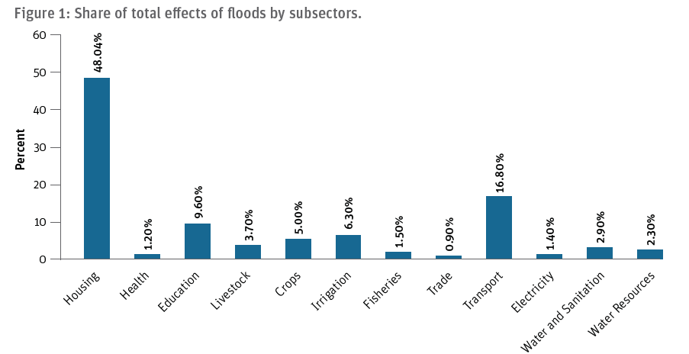

1.1.1 **Flood warning procedure in Malawi**

There are different models and services put in place by the Malawian govt and people to warn on incoming flood

1. DCCMS is mandated to monitor, predict and provide information on weather, climate and climate change ,that would contribute towards the socio-economic development of the country. DCCMS Short-range weather Forecasts (24-hours-3days); • Medium-range weather forecasts (7-days, 10 days or decadal); • Long-range forecasts (a monthly or more) and seasonal weather outlook)
2. DWR id mandate to achieve sustainable and integrated water resource management and development that make water readily available and equitably accessible to and used by all Malawian. DWR -Flood Warnings Services ─ provision of tailor-made forecast (as a decision support tool ) for planning and preparedness by weather and climate sensitive sectors; • wide range of forecasts for aviation, marine, water resource, agriculture and insurance • Lightening advisory and flash flood guidance, Dry spells and drought advisories, Flood forecasting & warnings by DWR

**1.2 Data Visualization**

According to Wikipedia, Data visualization is the graphic representation of data. It involves producing images that communicate relationships among the represented data to viewers of the images. This communication is achieved through the use of a systematic mapping between graphic marks and data values in the creation of the visualization. This mapping establishes how data values will be represented visually, determining how and to what extent a property of a graphic mark, such as size or color, will change to reflect changes in the value of a datum. According to Vitaly Friedman (2008) the "main goal of data visualization is to communicate information clearly and effectively through graphical means. It doesn't mean that data visualization needs to look boring to be functional or extremely sophisticated to look beautiful. To convey ideas effectively, both aesthetic form and functionality need to go hand in hand, providing insights into a rather sparse and complex data set by communicating its key-aspects in a more intuitive way.

The common visualization techniques are divided into three categories: data visualization, information visualization, and interactivity (Khan & Khan, 2011). Data visualization is the study of the visual representation of data, which means information that has been abstracted in some schematic form, including attributes or variables for the units of information. In contrast, information visualization concentrates on the creation of approaches for presenting abstract information in intuitive ways (Thomas and Cook, 2005)

1. **Report/Research Objectives**

**3.0 DATA AND METHODS**

We examined relationships between floods and food security

Gathering data

3.1 Deriving food security indicators

Antenatal Care provider statistics from 2010 to 2017

4. 0 LIMITATIONS

We found variability in results between the regions in Malawi. However, the analysis is limited by data availability, as the DHS samples are too small to look at regions within-country variability. A related limitation is the spatial scale of the analysis. DHS samples are rarely representative within sub-national regions, which limits our ability to examine the flood exents within specific regions of a country. This modest number of clusters means that some areas that are flood or drought prone may not be covered by the DHS data, limiting our ability to test robustness.

In this study, we have not investigated factors that influence the vulnerability of households to flooding such as the building quality, or other determinants of flood impacts such as flood duration, (Dang et al., 2010; Parker et al., 1987), and its impact on indirect losses such as loss in output and revenue and economic disruption (Lekuthai and 382 Vongvisessomjai, 2001) and flood-related health issues; and flood level rise rate which is 383 especially important in terms of mortality (Jonkman et al., 2009).

1. CONCLUSION

The general conclusion of this report is that poor people are disproportionally exposed to rural floods. A particular concern is the fact that some of the regions where poor people are overexposed will also experience more frequent flooding in the future due to climate change. Government should enforce land-use regulation, risk-sensitive land-use policies that protect poor people, such as flood zoning and land entitlement support the access of poor people to opportunities and not stifle them. The results suggest that integrating local knowledge in developing localised and relevant climate change adaptation strategies is essential in Malawi. This can be achieved by creating a forum for interaction between scientists and indigenous knowledge holders.

References

Malawi 2019 Floods Post Disaster Needs Assessment Report, 2019

Er-Xuan Sung, Meng-Han Tsai, Shih-Chung Jessy Kang , An Interactive Data Visualization System for Flood Warnings in Taiwan, 2013

Standard Operating Procedure for Early Warning System in Malawi

Government of Malawi. 2010. Second National Communication of Malawi. Ministry of Natural Resources and Environmental Affairs, Lilongwe, Malawi.